Jennifer Stegina

20 September 2019

CIS 250

**Unit 4 Guided Practice 3**

The following questions come from the Task examples in Chapter 14 in your textbook.

After you are finished, please submit a Microsoft Word file that contains screenshots of the SQL Queries, the output, and put a comment line in the query with your last name. Your document should be named **U4_GuidedPractice3_Lastname.docx**.

(14-1) Question 1:

Show the inner join of the *twos* table and the *threes* table. Make a list of the rows of the beginning tables that are dropped from the result table.

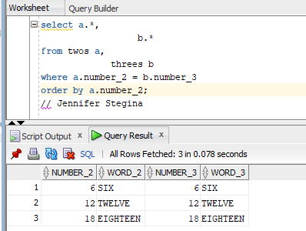

(14-2) Question 2:

For the *twos* table and the *threes* table, show the results of the three types of outer joins.

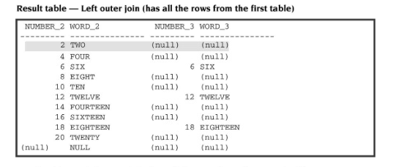

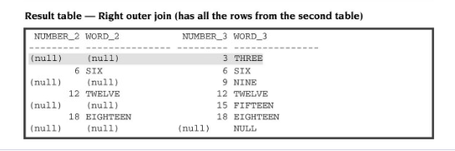

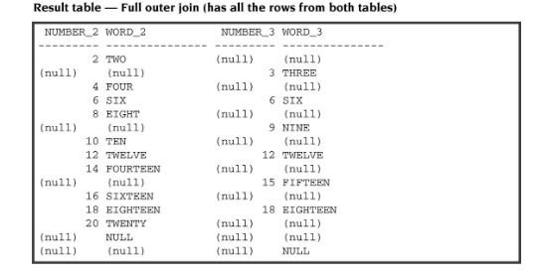

(14-3) Question 3:

Show the syntax to write a left outer join.

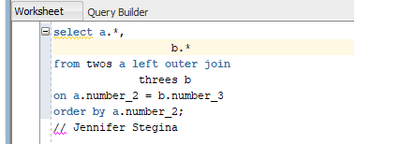

(14-4) Question 4:

Show the syntax to write a right outer join.

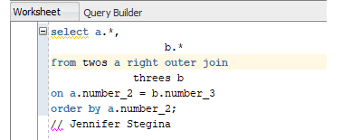

(14-5) Question 5:

Show the syntax to write a full outer join.

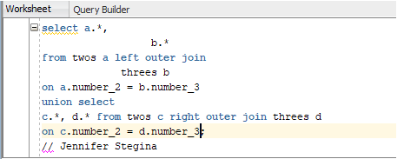

(14-6) Question 6:

Show how to write a *union* in SQL. Show the *select* statement for the preceding diagram. Write the *select* statement so that its result table is table C in the diagram.

Select * from A

Union

Select * from B;

(14-6) Question 7:

Show another way to write the SQL for the preceding diagram. Write this SQL to create table C as a new table.

Insert into B select * from A;

Create table C as select distinct * from B;

(14-7) Question 8:

Show an example of a *select* statement that uses a *union*.

